Multilayer Perceptron Model (MLP)
To understand what is a MLP or neural networks in general we need to start from the basics. A neural network is inspired by our biological neurons, which are interlinked and share information amongst each other to generate a certain output (be it a thought or action).
Similar to how our brain works, neural networks are made up of tiny units called neurons which (shocker) also are interlinked, share information and generate a certain output.
This document is my effort to not to teach you the syntax of how to use VOLT but more importantly how to understand what is a neural network and how does it work and learn.

Neuron
Our journey starts from a humble single neuron. It takes N inputs and 1 output.
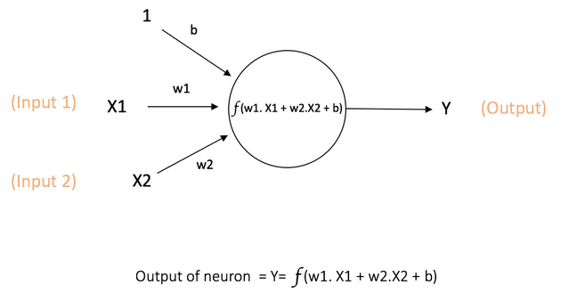
In a provided image X1 and X2 are 2 inputs to the circle (neuron) which generates an output Y. Whereas w1, w2 are weights and b is the bias.
To understand better what exactly is going on let’s run through a simple analogy.
Let’s say you want to decide whether or not you want to buy new clothes. In this case you have two possible outcomes
- You do buy new ones (we’ll denote that by 1)
- You do not buy new ones (we’ll denote that by 0)
Hence Y can either be 0 or 1.
Now you ask for 2 of your friends/family for their opinion on whether or not you should buy new clothes. This means you have 2 inputs. Realistically speaking, there might be a difference of opinion or what not but you will most likely give different amount of importance to either of the opinions; this amount of importance we can call weights of their opinion/input.
That leaves bias. Now regardless of what either one is saying you feel like buying clothes so you inline more towards the outcome being 1.
Converting these statements into some mathematical values we get
- Y is either 1 or 0
- X1 let’s say is Yes (1) and X2 let’s say is No (0).
- Bias let’s say is 0.3.
- w1 and w2 are 0.1 and 0.5 respectively.
Doing weighted sum as provided in the picture we can get the output Y
Y’ = X1 * w1 + X2 * w2 + b
Y’ = 1 * 0.1 + 0 * 0.5 + 0.3
Y’ = 0.4
Now we can see that the output is not exactly either 0 or 1 as discussed earlier. We can apply a simple step function here with the definition

Y = 1 if Y’ >= 0.5 else 0

We can assume that this is step function is the function represented in the picture.
Essentially, Neurons take input, process them and give an output.

Activation functions
We mentioned a step function before but usually we use activation functions here. These activation functions allow us to introduce non-linearity in our system. But what’s non-linearity? Let’s try and visualize a simple problem first
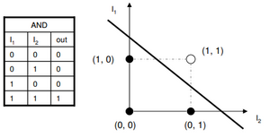
AND gate is linear problem. Why? Because its outcomes can be divided using a single straight line. Same goes for OR gate. But a special case is seen when I observe XOR gate.
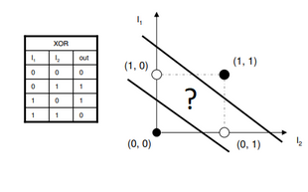
Theirs is no single straight line you can draw to divide its outcome.
If a problem whose outcomes cannot be divided using a single straight line those problems are non-linear and require some non-linear functions for the approximation of their outcomes.
Some common activation functions are Sigmoid, ReLU, Leaky ReLU and so on. We’ll discuss these later in detail their importance and which activation function to choose for what problem.
Following is a sample code implemented in VOLT for XOR.

DataUtility::DataMatrix<float> X = {
{0.0f, 0.0f},
{0.0f, 1.0f},
{1.0f, 0.0f},
{1.0f, 1.0f}
};

DataUtility::DataMatrix<float> y = {
{0.0f},
{1.0f},
{1.0f},
{0.0f}
};

MultiLayerPerceptron model(X.cols, Regularization::None, 0.0f, Loss::Type::BinaryCrossEntropy, new SGD(0.1f));
model.addLayer(2, Activation::ActivationType::Sigmoid);
model.addLayer(1, Activation::ActivationType::Sigmoid);
model.train(X, y, 20, 4);

std::cout << "Accuracy: " << model.evaluate(X, y) * 100 << '\n';

Now it’s fine if you do not a lot of this since all of this will be explained down the article.

Neural Network (NN)
Now that we understand what a neuron is, what about a whole network of them? Similar to how they actually work in our brain. Interlinking these neurons gives them a lot of power since each neuron can essentially do part of the work and pass it on. This way a lot of “low memory” neurons collectively become “specialized workers” for a problem they’ve been trained on.
But we missed one point. Though activation functions bring non-linearity, it is also necessary that we use more than 1 neuron. We add neurons in layers (imagine stacking horizontal grouped neurons on top of on another). In our previous example, the lines can be visualized by the image

model.addLayer(2, Activation::ActivationType::Sigmoid);
model.addLayer(1, Activation::ActivationType::Sigmoid);

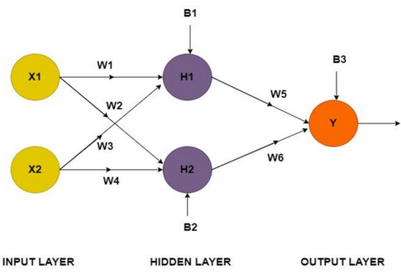

We added two stacks on neurons.
Layer Type | Neuron Count | Activation Function | Role in Model
Hidden Layer | 2 | Sigmoid | Processes input combinations to find non-linear patterns.
Output Layer | 1 | Sigmoid | Squashes the final result into a 0 or 1 prediction.

What’s the input layer? Well in reality this “layer” does not exactly exist (hence no neurons either) rather used in image to help understand the entry of data into the neural network. The X1 and X2 are the inputs 0 and 1 (value of logical input) in Data matrix X in code.
NOTE: In an MLP, all neurons in a layer are connected to all other neurons in their adjacent layers.
So, what’s happening? Both input X1 and X2 enter the H1 and H2 neurons. They process the input using weighted sum, may pass the output through some activation function which in the end reaches to Y which again processes the inputs from H1 and H2 using weighted sum (+ maybe activation function) and finally outputs the result.
NOTE: The reason I now am saying “maybe activation function” is because some times especially when predicting continuous values, you do not use an activation function. This is done differently in different frameworks but in VOLT no activation function is done by

model.addLayer(n, Activation::ActivationType::Linear);

Training of neural networks
Now we’re moving on to how neural network learns. Essentially the training process can be divided into 2 steps. Forward pass and Backward propagation.

Forward pass
As mentioned above the process of how X1 and X2 will be processed and reach output is called forward pass. This is what the model infers from the input. As for one-liner explanation of the whole process it can be said that each layer sends its output to the next until result is calculated.

Intermediate steps
Before we move on to the magic “Back Propagation” there are some intermediate steps. Since these parts include some calculus, I will try to simplify the whole process of it, the why and the hows as much as I can. Buckle up! Some technical terms are about to be introduced.

MultiLayerPerceptron model(
static_cast<int>(X_train.cols), // input size
Regularization::L2, // regularization type
0.005f, // lambda (regularization strength)
Loss::Type::CategoricalCrossEntropy,// loss function
new Adam(0.01f) // optimizer (learning rate = 0.01f)
);

Take a look at the code snippet here. The constructor model takes parameters
INPUT SIZE: The number of features we have in our dataset is known as input size. Since in our previous examples we had input X1 and X2, the input size will be 2.
REGULARIZATION TYPE: This helps in tuning the complexity of the model. (More on this later).
LAMBDA: How much we want to reduce the complexity of the model (this is usually a very small value).
LOSS FUNCTION: How will we determine how far off our model’s output was from the actual expected output.
OPTIMIZER: This helps in how our model learns better and quicker (this is very complex and will have its own section).

Out of all these, right now we are interested in the Loss function. Once we get our output we need to know if our output was correct or not? Or close enough or not? Though it is not directly used in training it plays a very important role.

NOW THIS NEEDS A BIT OF ATTENTION
We need to minimize our loss (the output of the loss function). Recall to how we minimize a function using calculus.
- We calculate its derivative (Gradient function)
- We equate the derivative to 0 (this gives points in our graph where the loss function’s value is either at local minima or maxima since at these points derivative of a function is 0).
- For all those points we check which points gives the value of the second derivative of the loss function’s value > 0. (In calculus this means from left to right at this point the graph is rising so this is a local minima).
Now for simple problems doing this whole process might work but what if instead of 2 or 3 dimensions we are faced with 786 dimensions (MNIST hand written number recognition problem). These steps are not viable for this case. Instead, what we do is use a method called Gradient Descent (GD).
What happens is that after forward pass we check where we are in our function by plugging relevant values in our Gradient function. The gradient tells us if we go in given direction, we will reach the top but since we want to minimize, we go in the opposite direction to minimize loss function. This allows us to approximate at what state our model will give the lowest loss.

Back Propagation

